**Website:Facebook**

Step 1: **Create-** Sign up Using Personal Information

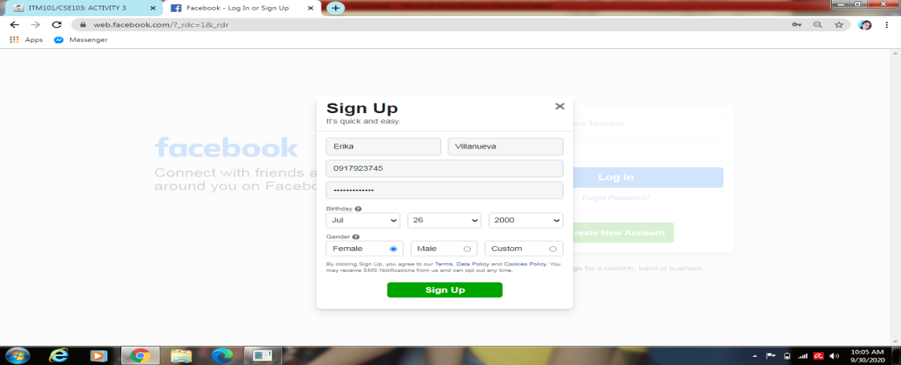

Step**: 2 Retrieve**- Search Any information To the website

**Facebook** is a social networking site that makes it easy for you to connect and share with family and friends online. Originally designed for college students, **Facebook** was created in 2004 by Mark Zuckerberg while he was enrolled at Harvard University.

Facebook is a [social networking](https://www.lifewire.com/what-is-social-networking-3486513) website where users can post comments, share photographs, and post links to news or other interesting content on the web, chat live, and watch short-form video.

Shared content can be made publicly accessible, or it can be [shared](https://www.lifewire.com/see-who-shared-post-facebook-4580318) only among a select group of [friends or family](https://www.lifewire.com/give-gifts-using-facebook-4103717), or with a single person.

Step:3 **Update**-update your personal information

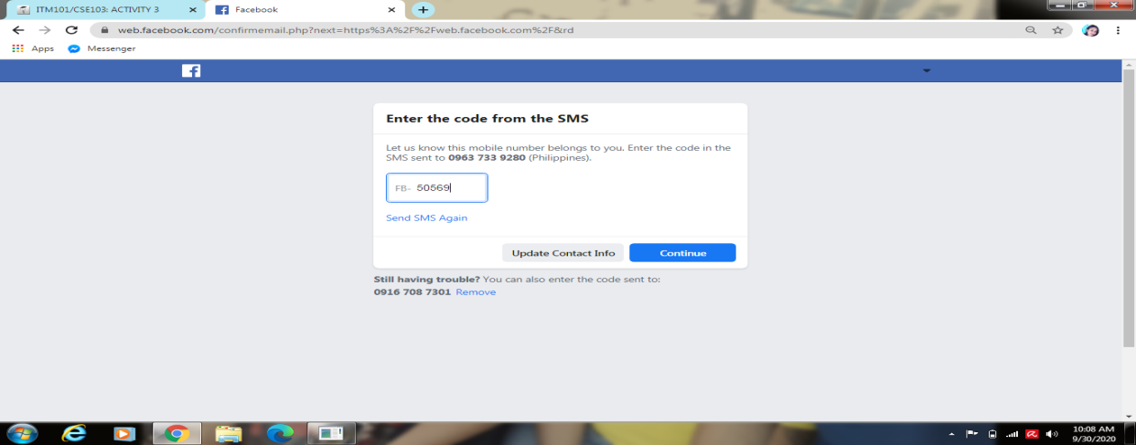

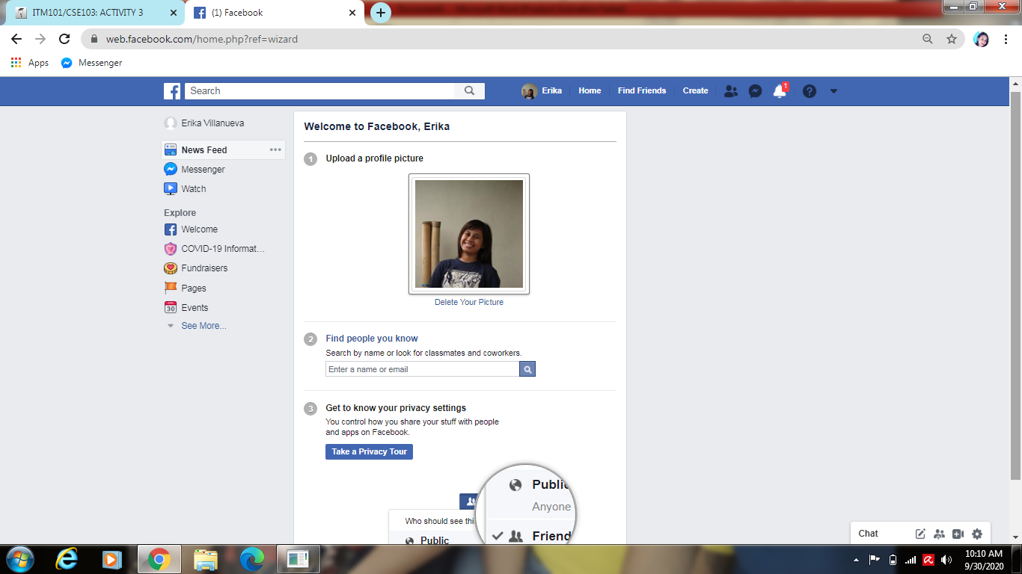

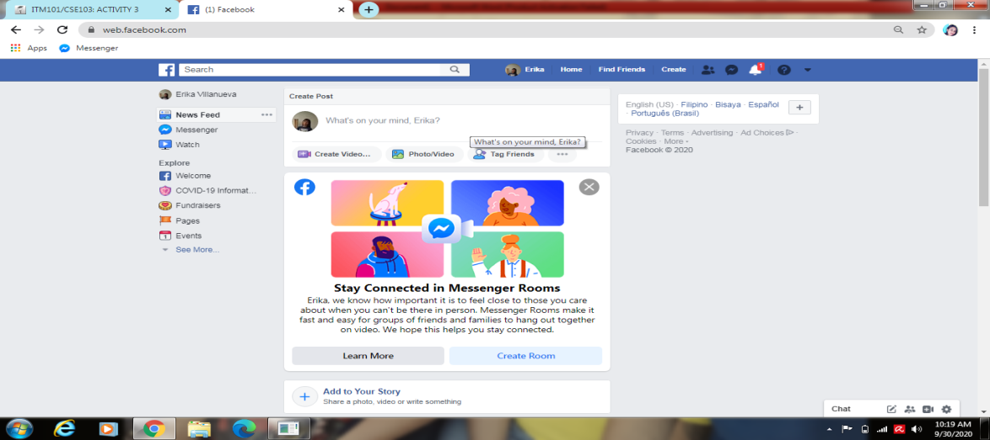

**Step:4 Delete-** delete or deactivate your account

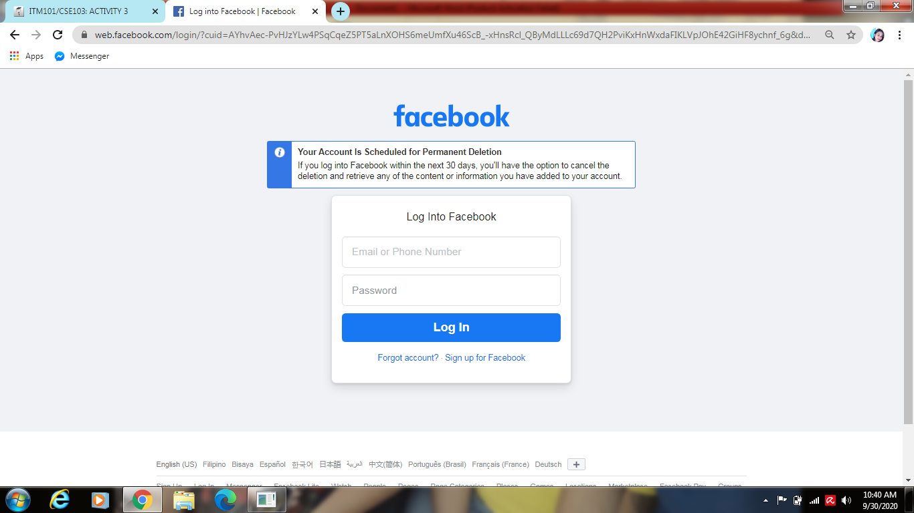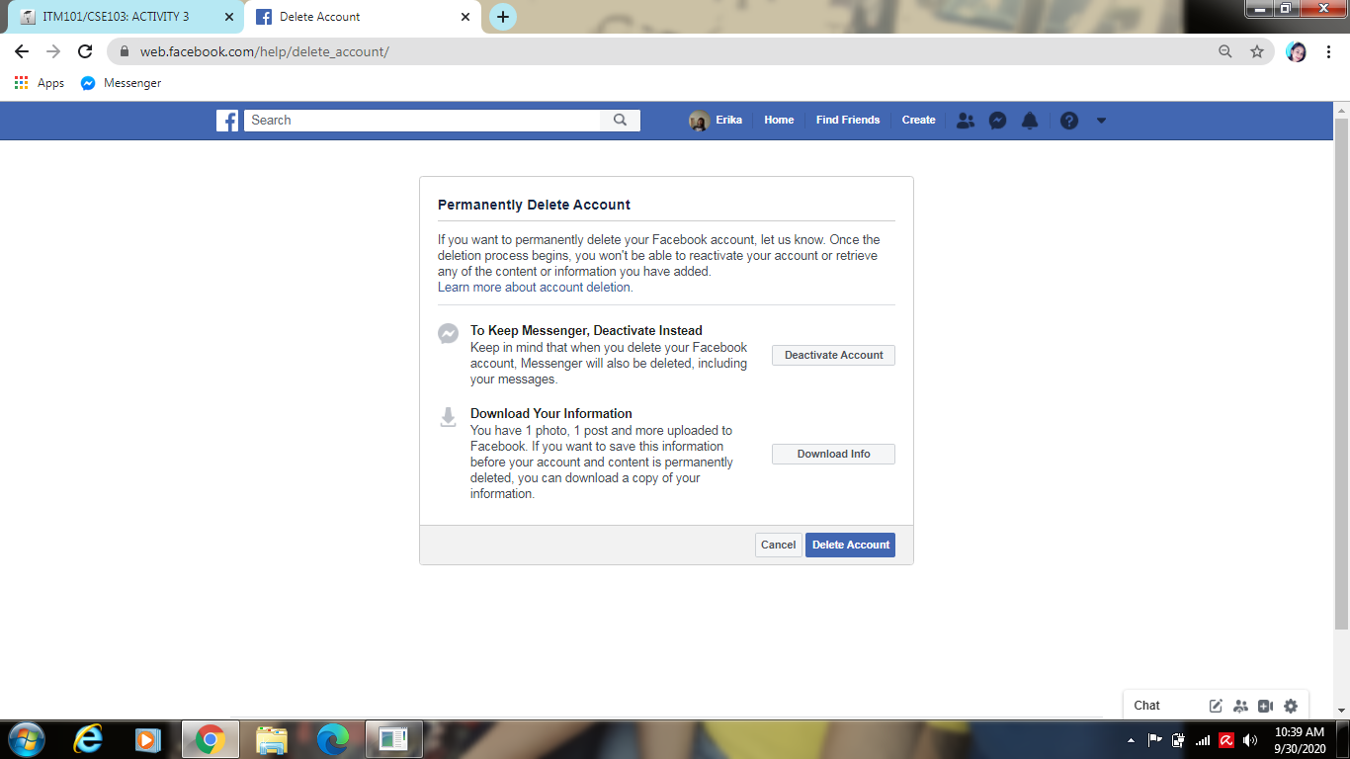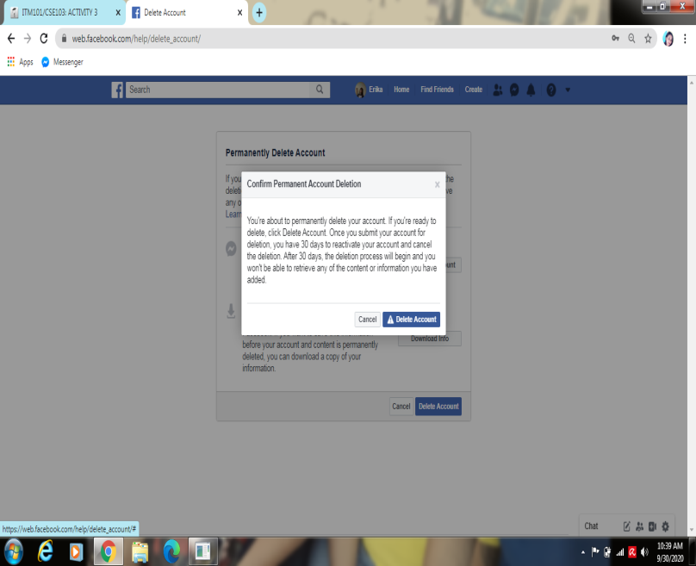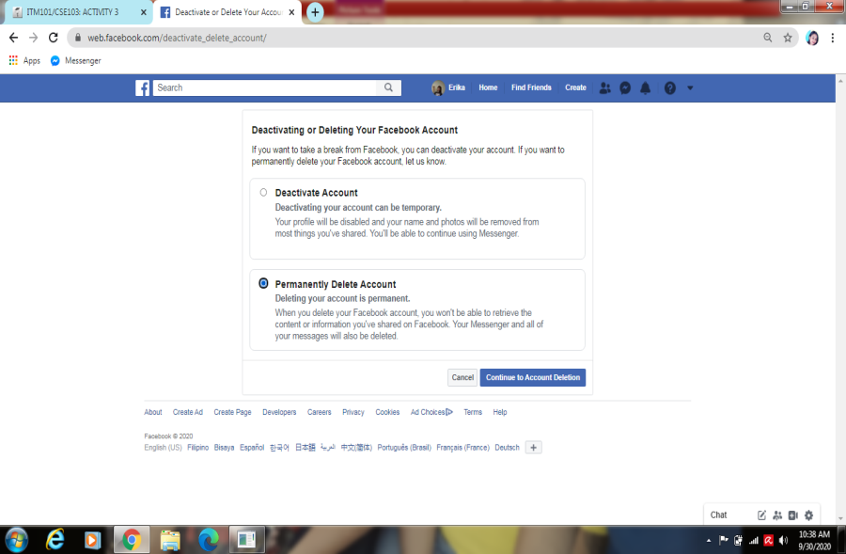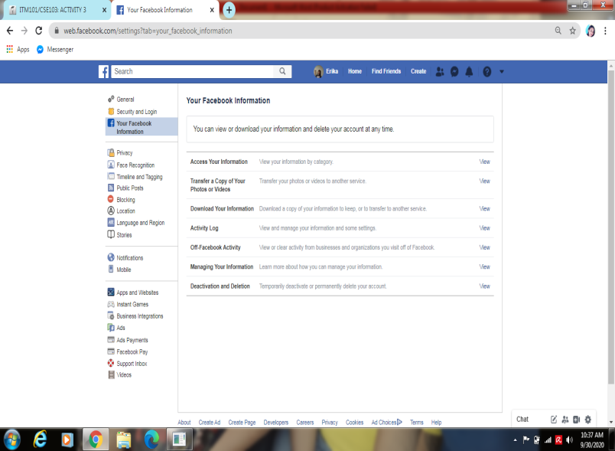

**Website: Twitter**

Step 1: **Create-** signup using your personal information

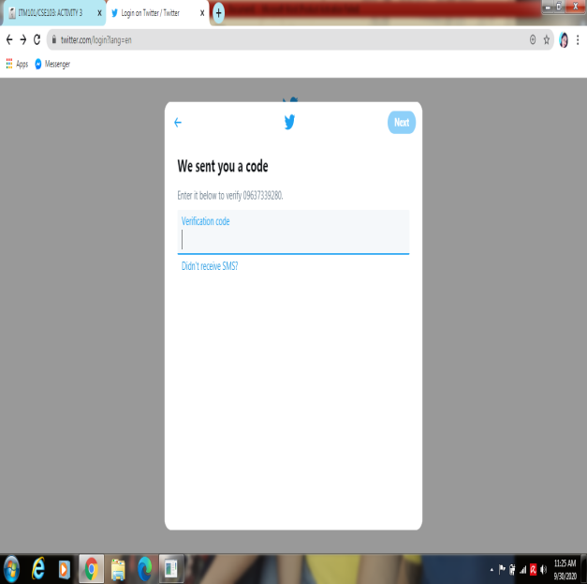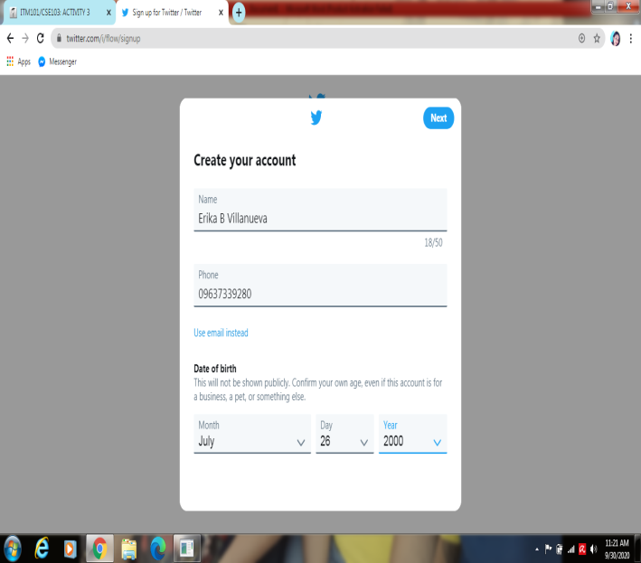

Step 2: **Retrieve-**search any information to the website

2006, Jack Dorsey, co-founder of Twitter, had an idea -- he would create a SMS-based communications platform in which friends could keep tabs on each other by updating statuses. In the beginning, Twitter was an idea all-too-similar to texting. The idea evolved, in large part due to brainstorming sessions with Dorsey's co-founder, Evan Williams.On March 21, 2006, Jack sent the first tweet, which read -- "just setting up my twttr."

Twitter saw [**explosive growth at the 2007 South By Southwest Interactive conference**](https://techcrunch.com/2011/01/04/twitter-foursquare-sxsw/), during which more than 60,000 tweets were sent. The Twitter team took advantage of the conference to begin growing their user base.

Twitter began as an SMS-based platform, so the 140 character limit was initially simply a necessity -- mobile carriers imposed the limit, not Twitter.

However, as Twitter grew to become a web platform, they kept the limit simply because it aligned with Twitter's brand -- Twitter is a platform that aims create highly skimmable content for our tech-heavy, attention-deficit modern world,

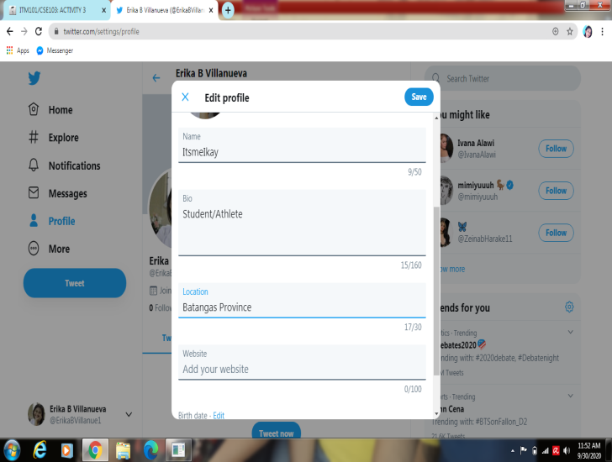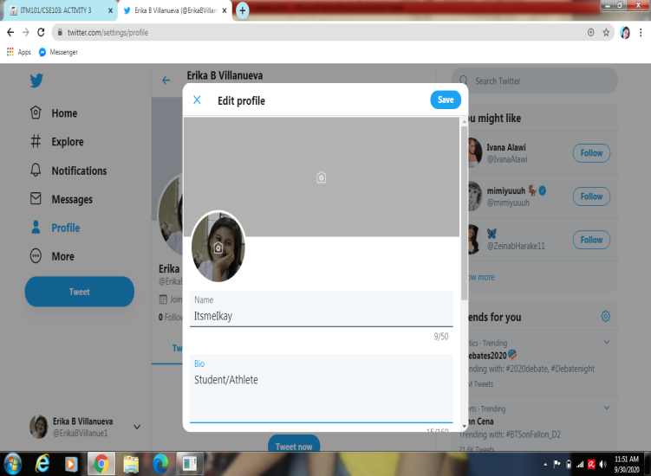**Step 3: Update-**update your personal information

**Step 4:Delete**- delete or deactivate your account

